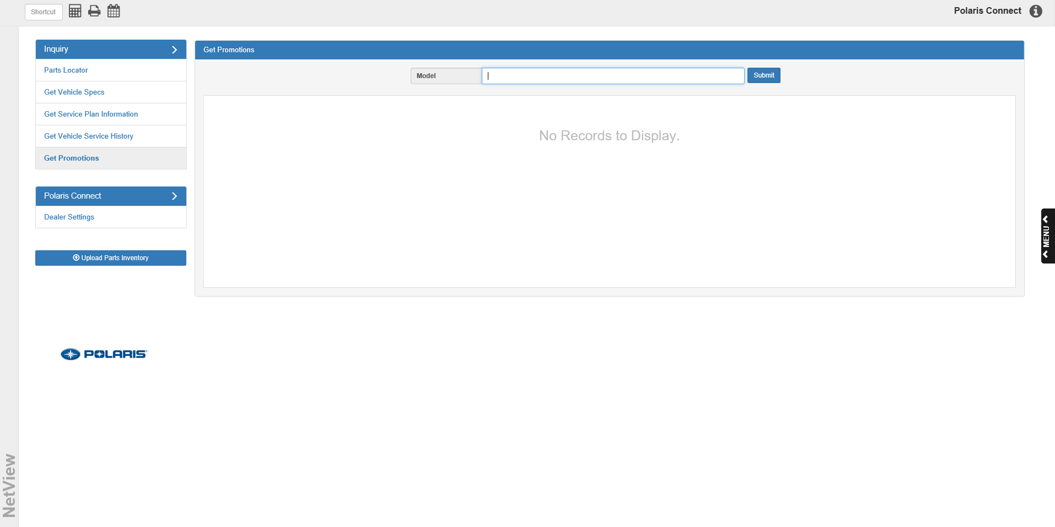
Get Promotions Tab
The Get Promotions inquiry tab is a new feature in Polaris Connect that allows you to look up information about available promotional offers concerning specific Polaris models.

Model
To see if a particular model has any available promotions, enter the model number here.

Submit
Click this button to begin the search. If one or more promotions are available, the promotion information will populate the screen:
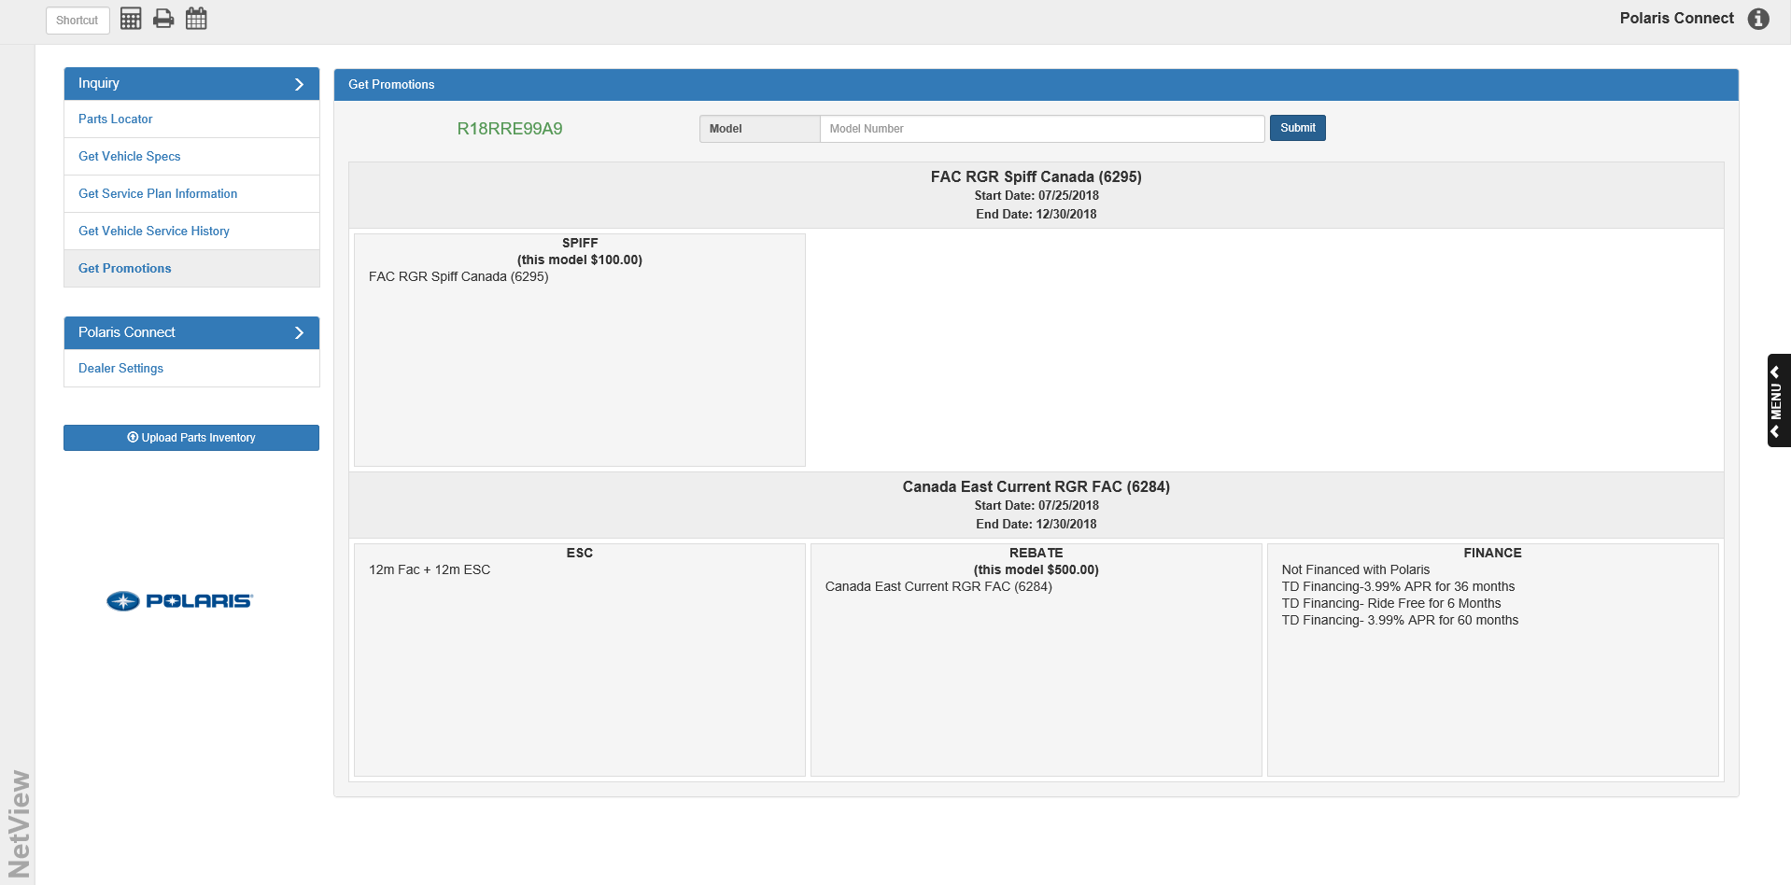


Promotion Results Display
The model’s available promotions will show in blocks: a header to indicate the promotion name, and sections below it displaying the details of the different promotion types available. Polaris makes up to 5 promotion types available for their models:

- Spiff
- ESC
- Rebate
- Finance
- Extended Warranty

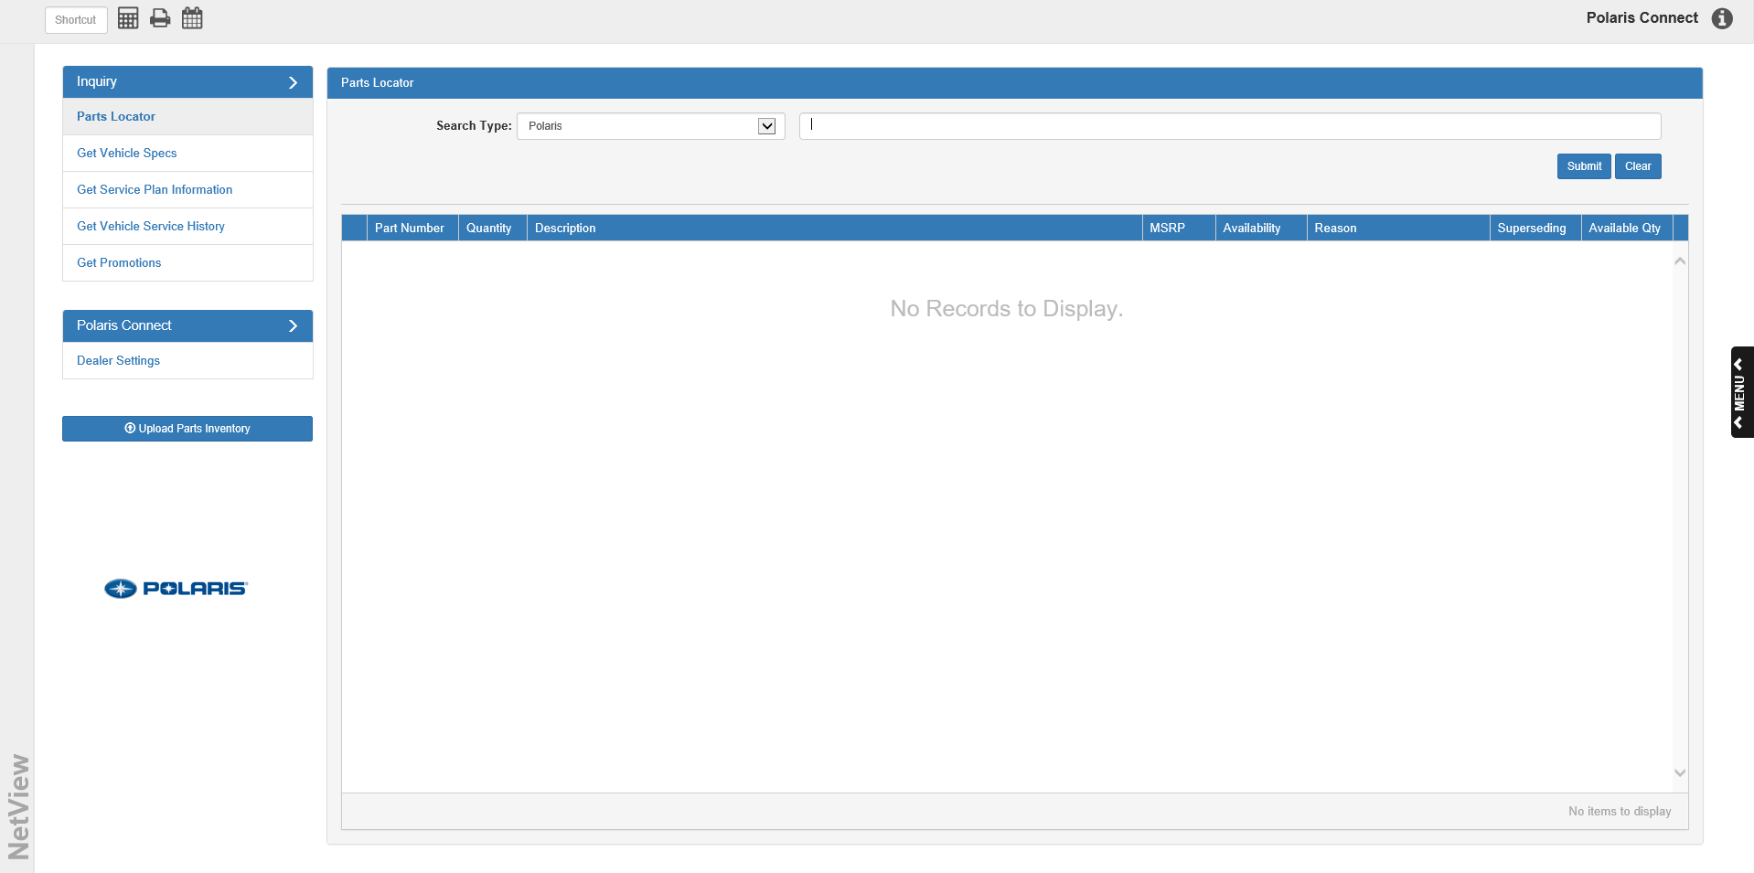

Parts Pricing Updates
Additionally, Polaris now makes Parts Pricing updates available daily Monday through Friday. The updates will automatically occur through ECLIPSE, so no action is required on the part of the user.

